Updating Outlook Categories through LegCRM

The outlook inbox has two classification features;

* Focused vs. Other (tabs)
* Categories

If you request that LIS enable category updates for your office, LegCRM will update you outlook inbox with the following categories:

* Bulk – email sent by automated system to multiple recipients
* Advocacy – individual email, but likely part of a campaign of identical emails
* Out of district – email includes a street address outside the office district
* Constituent – email includes a street address inside the office district
* Senate, House, .Gov – based on the sender’s email address.

Emails tagged as Bulk, Advocacy and/or Out of District will be placed in the “Other” tab. All other email will appear in the “Focused” tab.

The screen shot below shows a view of the “Other” tab contents in a sample inbox: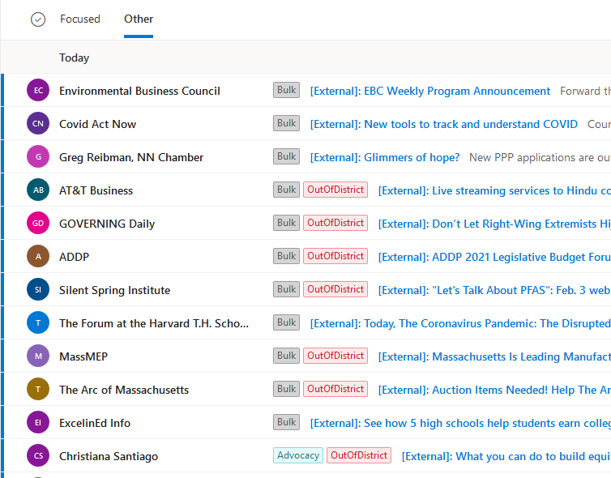

You can click on a tag to select all similarly tagged messages.

To choose your colors for tags, click the Gear symbol for settings at the top right, then click “View all Outlook Settings” at the bottom right, then select “General” at the top left and then categories from the menu that appears. The click “Create category” and type the exact name of the category that you want to assign a color to – probably you want to do all of them, one-by-one as listed below.

